Shell GPT (SGPT) Installation & Configuration on Ubuntu LXC (Step-by-Step)

Overview
This document describes a simple, step-by-step procedure to install and configure Shell GPT (sgpt) inside an Ubuntu LXC container. It's written for non-technical users and includes exact commands to copy and paste.

Prerequisites
• An Ubuntu LXC container (you can access its terminal).
• Internet connection inside the container.
• An OpenAI API key (starts with sk-...). If you don't have one, create it at https://platform.openai.com/api-keys.

Important notes before you start
• Copy and paste each command into the container terminal and press Enter.
• If a command asks for confirmation, type 'y' and press Enter.
• The steps below install sgpt in a safe isolated way using pipx (recommended).

Steps (copy-paste commands one by one)
1. Update the container's package list and upgrade installed packages:
- sudo apt update && sudo apt upgrade -y
2. Install Python and pipx (needed to install sgpt safely):
- sudo apt install python3 python3-pip python3-venv pipx -y
3. Ensure pipx is available in your shell path (so 'pipx' command works):
- pipx ensurepath
- After this, close and reopen the terminal OR run:
- source ~/.bashrc
4. Install Shell GPT (sgpt) using pipx:
- pipx install shell-gpt
5. Configure your OpenAI API key (used to let sgpt talk to OpenAI):
- Run the interactive configuration and paste your API key when prompted:
- sgpt --configure
- If you prefer, set the key manually (replace sk-your-key with your real key):
- echo 'export OPENAI_API_KEY="sk-your-key"' >> ~/.bashrc && source ~/.bashrc
6. Test sgpt with a simple question:
- sgpt "Explain DHCP in one line"

What to expect
• After the test command you should see a short AI-generated answer printed in the terminal.
Check | Command | Expected Result
Python installed | python3 --version | Shows Python version (e.g., 3.10.13)
pipx installed | pipx --version | Shows pipx version
sgpt installed | sgpt --version | Shows sgpt version
API key set | echo $OPENAI_API_KEY | Shows key (masked)
Functional test | sgpt "Hello" | Returns an AI response in terminal
• If everything works, sgpt is installed and can be used in that container.

Verification Checklist

Troubleshooting (common problems & fixes)
1) pipx command not found after 'pipx ensurepath' -- Close the terminal and reopen it, or run:
- source ~/.bashrc
2) 'permission denied' or 'externally-managed-environment' errors -- Use pipx as shown above; do NOT use 'pip install' system-wide.
3) sgpt not found after installation -- Ensure pipx path is active (run 'pipx ensurepath' and 'source ~/.bashrc'), then try:
- hash -r && sgpt --version
4) API errors or 'invalid key' -- Re-run 'sgpt --configure' and paste the correct API key. Ensure the key is active on your OpenAI account.

How to use (example commands)
sgpt "Write a bash script to check CPU usage"
sgpt "Explain what is DHCP in one line"
To create a short alias for convenience (optional):
echo 'alias ai="sgpt"' >> ~/.bashrc && source ~/.bashrc
Then use: ai "Generate a Python script to list files"

Short summary
1. Update packages. 2. Install Python and pipx. 3. pipx ensurepath. 4. pipx install shell-gpt. 5. sgpt --configure (enter API key). 6. Test with a sample prompt.

Contact / Notes for non-technical users
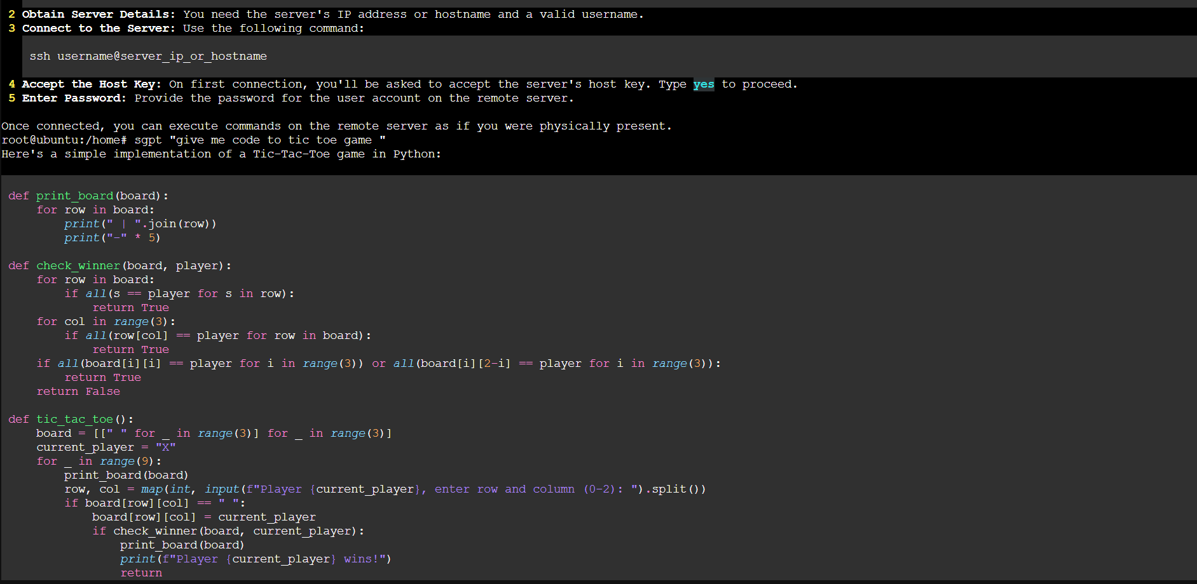
If you get stuck, copy the exact command you ran and the error message and share it with the person helping you. They can use that information to diagnose the issue quickly.
